18U ENCLOSURE 19" CABINET 600X1000 | 18U SERVER RACK CABINET FLOOR STANDING
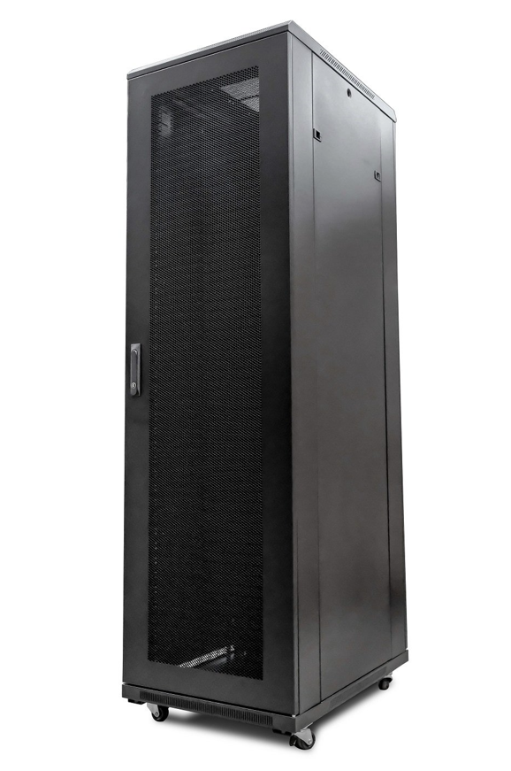

DESCRIPTION
Redefining quality compact ergonomics for server and networking
Looking to house your latest rackmount Server, SAN, UPS and other networking devices in a compact, universal server enclosure?
The new LMS Data CAB-FE-18U-6100 | 18U Server Rack Cabinet Floor Standing is one of the most compact server enclosures on the market today, but still has all the features IT integrators come to expect
from its larger counterparts. Full 19-inch wide, front and rear adjustable profiles
with a thicker gauge designed to carry the extra weight of a fully populated
server and of course, full 1000mm depth to house high--performance
servers but also allow adequate airflow.
Air-flow is further enhanced with front meshed door to allow ambient air
to be allowed to enter the active equipment and of course an integral
roof-fan tray will extract heated air safely away from the equipment, thus
increasing available up time for your mission-critical applications.

SPECIFICATIONS
ETSI 19” front/rear profiles (adjustable)
Universal server design for all popular servers, UPS, SAN & more*
Up to 800Kg static load bearing**
Front mesh high venting door (lockable)
Left/right hinged front/rear doors
Removable side panels for easy access
U-numbered uprights for rack-mount product alignment
Multiple cable entry glands for exact power and cabling entry
Fitted 4-way fan tray in raised and vented roof-space
Fitted vented shelf
Powder-coated RAL 9005 finish

TECHNICAL INFO
SKU/MPN: CAB-FE-18U-6100
EAN: 8400800022752
Weight: 50.0 Kg
Dimensions: 600x100x980mm

FILES
Datasheet - CAB-FE-18U-6100

